IB PHYSICS IA

Effect of the length of string on rate of energy dissipation

**Abstract**

The aim of this investigation is to find how varying the length of the string affects the rate of energy dissipation. This experiment uses an online simulation testing string lengths from 0.75 meters to 1.75 meters in increments of 0.25 meters with a ball of mass 1 kg hanging at the end. After measuring the time, height, and total energy of the ball every time it reaches the top of its path, I found that as the string lengths increases, the rate of energy dissipation decreases.

**Introduction**

The origin of this investigation comes from my experience playing piano. The mechanism for creating sound is a combination of hammers and strings. Whenever a key is pressed, the hammer connected to the string would strike the strings in the back of the piano. The vibrations created on the strings are then transmitted to the soundboard where the sound resonates throughout the piano and is spread to the surroundings[1]. Each note on the piano is a different and corresponds to a specific frequency or pitch. The most important factor in controlling pitch is the strings. They vary in length, diameter, tension, and density[2] to resonate with different frequencies. Usually, they use the same type of metal wire and diameter, so tension and length are the biggest determinants of pitch. Strings under more tension or are shorter vibrate faster leading to a higher pitch, than the longer and less taut string.

Another important aspect of the piano are the pedals, especially the right dampening pedal. Having played piano for the last twelve years, the right pedal is a crucial part of almost every piece I have performed. Its function is to sustain the note for a longer period of time and mellow out the sound. But one thing that confounded me was why the higher pitch notes would never sustain as long a period of time compared to the lower pitch notes. This was the case in all the pianos that I had played on even when I would press with the same force on the piano keys and the pedal. This was a factor that I often had to account for whenever I practiced and performed.

My investigation focuses on the propagation of sound, specifically why lower pitches propagate longer. Since sound can be converted into oscillating waves, it can be modeled through simple harmonic motion (SHM). The defining aspect of SHM is that the restoring force always opposes the orientation of displacement, or in other words, the acceleration (a) is proportional to the displacement (x) in the opposite direction.

SHM creates waves, which are the disturbances in a medium that carries energy, because particles/objects in motion return to the same position after a fixed period. Objects in SHM in the real word undergoes dampening which is when outside forces are removing energy from the system since it counters the motion in the system. There are three levels of dampening: underdamped, critically damped, and overdamped. In a long enough period, dampening will cause the system to reach an equilibrium[3] or state of rest since all the mechanical energy in the system has been converted to some other form and dissipated into the environment. In the piano, the dampening pedal sustains the sound by removing all the dampers so the strings can vibrate sympathetically with its neighboring strings, both increasing the volume and length of the sound. However, as sound propagates through the air, energy is lost to friction and absorbed into the air through classical absorption or relaxation process[4]. Simple Harmonic Motion are most often represented through spring oscillations and pendulums.

Like the piano, pendulums also oscillate in simple harmonic motion and their frequency is likewise dependent on the length of the string. This relationship can be represented by the equation:

where = length and g = acceleration due to gravity

Taking a further step, the amplitude representing the strength of the sound can now be represented using the highest height the pendulum reaches during its oscillations. The decrease in height would mirror how the volume of the sound declines. In addition, I can measure the energy through the height since at the peak of each swing, all the energy not lost to dampening is converted into gravitational energy quantified through the equation:

Then by comparing the change in gravitational energy (which is also total energy in the pendulum system) in terms of time, I can then find the derivative of each graph. The difference in steepness of the slope would indicate the rate of energy dissipation.

**Risk Assessment**

This experiment would be done using a simulation and an online ruler app so there is no harm to the environment, and neither are there any possible risks during the experiment.

**Variables**

*Independent variable:*

Length of the string – I will be using string lengths of 0.75 m, 1.00 m, 1.25 m, 1.50 m, and 1.75 m. Changing the lengths is reflective changing the frequencies.

*Dependent variables:*

Height reached – I will measure the maximum height displaced, setting the zero potential line at the lowest level of its path.

Energy – I will measure both the potential gravitational energy through the height and use the simulation to collect data on their measured Total energy.

*Controlled variables:*

Mass – I will hang a mass of 1 kg at the end of each pendulum to ensure that same amount of gravitational force for each string.

Level of Dampening – set at level .100 to ensure that the dissipation of energy is solely due to string length rather than varying levels of dampening or external forces to the system.

Simulation – the same simulation would be used to ensure the constants listed earlier and the same environment and measuring scale for each pendulum.

Drive amplitude/frequency – both set to zero, so no other external force is presen

**Hypothesis**

Null Hypothesis: No relationship is found between the length of the string and the rate of energy dissipation.

Alternate Hypothesis: If the length of the string the increased then the rate of energy would decrease where the amplitude squared is directly proportional to the total energy of the system.

**Materials**

* Pendulum simulation (<https://www.myphysicslab.com/pendulum/pendulum-en.html>)
* Ruler app

**Diagram 1: Simulation Set Up**

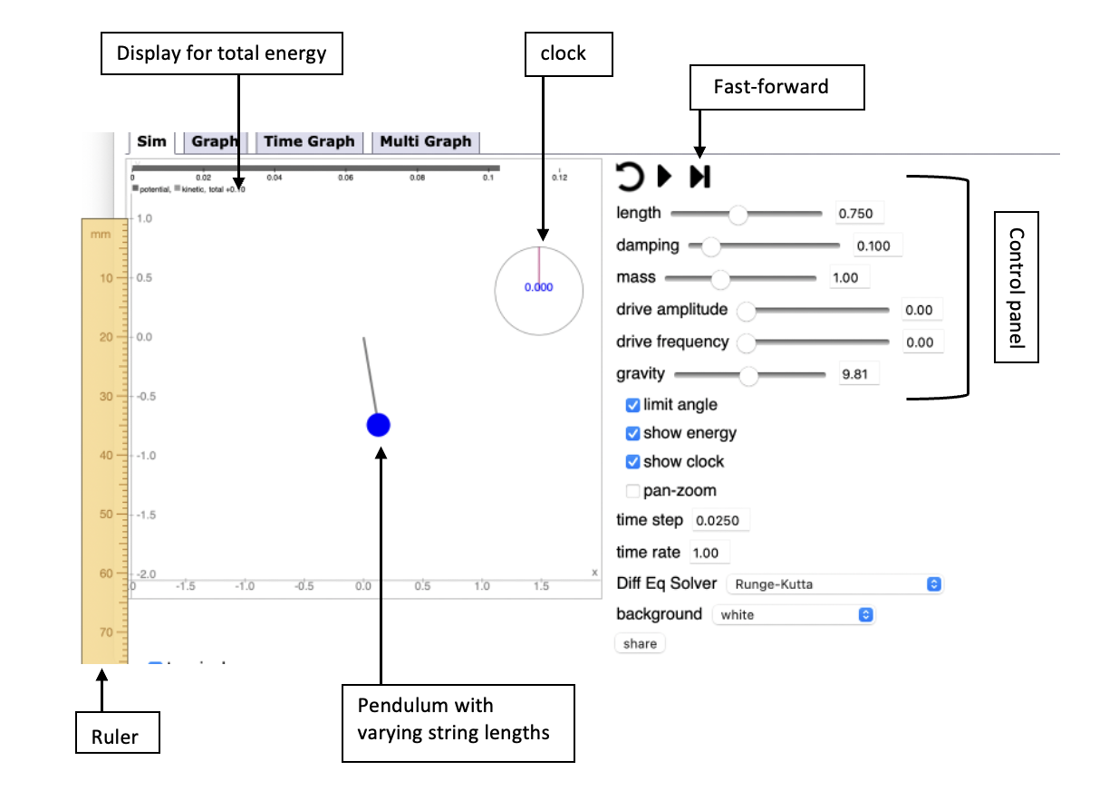

**Procedures**

1. In the control panel, set drive frequency and drive amplitude to 0.00, damping to 0.100, mass to 1 kg, time step to 0.0250, and gravity to 9.81 m/s^2
2. Open clock and calibrate it to zero
3. Set the length to 0.75 m
4. Lift the ball to a height of 0.5 m from its initial resting state for a total energy measurement of 5 J
5. Press the fast-forward button till the ball reaches a new peak (when the energy bar at the top is all potential energy)
6. Record the height, time, and total energy
7. Repeat steps 5-6 for six consecutive peaks after the initial starting point of 0.5 m
8. Repeat step 3-7 three times
9. Repeat steps 3-8 for different lengths till 1.75 m in increments of 0.25 m

*Data Table 1: Raw Data, varying L measuring height, time, and total energy*

*Data Table 2: averaging the raw data*

|  |  |  |  |  |
| --- | --- | --- | --- | --- |
| **AVERAGED DATA** | | | | |
| **L = 0.75 M** | | | | |
|  | Average Height (m) | Avg Ug (J) | Average Time (s) | Avg Total Energy (J) |
| Initial | 0.50 | 4.91 | 0.000 | 5.00000 |
| 1st peak | 0.43 | 4.22 | 0.950 | 4.22719 |
| 2nd peak | 0.36 | 3.56 | 1.917 | 3.61758 |
| 3rd peak | 0.30 | 2.98 | 2.825 | 3.22415 |
| 4th peak | 0.26 | 2.52 | 3.742 | 2.68742 |
| 5th peak | 0.22 | 2.19 | 4.667 | 2.24785 |
| 6th peak | 0.19 | 1.86 | 5.558 | 1.91829 |
| **L = 1.00 M** | | | | |
|  | Average Height (m) | Avg Ug (J) | Average Time (s) | Avg Total Energy (J) |
| Initial | 0.50 | 4.91 | 0.000 | 5.00000 |
| 1st peak | 0.47 | 4.61 | 1.083 | 4.66419 |
| 2nd peak | 0.42 | 4.15 | 2.142 | 4.22251 |
| 3rd peak | 0.38 | 3.70 | 3.208 | 3.78747 |
| 4th peak | 0.33 | 3.20 | 4.268 | 3.41415 |
| 5th peak | 0.29 | 2.84 | 5.317 | 3.07811 |
| 6th peak | 0.25 | 2.42 | 6.367 | 2.78812 |
| **L = 1.25 M** | | | | |
|  | Average Height (m) | Avg Ug (J) | Average Time (s) | Avg Total Energy (J) |
| Initial | 0.50 | 4.91 | 0.000 | 5.00000 |
| 1st peak | 0.47 | 4.61 | 1.167 | 4.69115 |
| 2nd peak | 0.43 | 4.25 | 2.350 | 4.36518 |
| 3rd peak | 0.40 | 3.89 | 3.525 | 4.04990 |
| 4th peak | 0.36 | 3.53 | 4.700 | 3.76367 |
| 5th peak | 0.32 | 3.14 | 5.867 | 3.49806 |
| 6th peak | 0.29 | 2.81 | 7.017 | 3.25080 |
| **L = 1.50 M** | | | | |
|  | Average Height (m) | Avg Ug (J) | Average Time (s) | Avg Total Energy (J) |
| Initial | 0.50 | 4.91 | 0.000 | 5.00000 |
| 1st peak | 0.48 | 4.68 | 1.267 | 4.74752 |
| 2nd peak | 0.44 | 4.35 | 2.542 | 4.49014 |
| 3rd peak | 0.41 | 4.05 | 3.817 | 4.24696 |
| 4th peak | 0.38 | 3.76 | 5.083 | 4.01722 |
| 5th peak | 0.37 | 3.63 | 6.375 | 3.80013 |
| 6th peak | 0.35 | 3.40 | 7.642 | 3.61464 |
| **L = 1.75 M** | | | | |
|  | Average Height (m) | Avg Ug (J) | Average Time (s) | Avg Total Energy (J) |
| Initial | 0.50 | 4.91 | 0.000 | 5.00000 |
| 1st peak | 0.47 | 4.64 | 1.358 | 4.76825 |
| 2nd peak | 0.45 | 4.38 | 2.733 | 4.56252 |
| 3rd peak | 0.43 | 4.22 | 4.083 | 4.36592 |
| 4th peak | 0.41 | 4.02 | 5.492 | 4.17778 |
| 5th peak | 0.38 | 3.73 | 6.850 | 3.99797 |
| 6th peak | 0.35 | 3.47 | 8.208 | 3.49196 |

*Data Table 3: Amplitude vs. Energy*

|  |  |  |
| --- | --- | --- |
|  | amplitude ^2 | total energy (J) |
| initial | 0.25 | 5.00000 |
| L = 0.75 | 0.18 | 4.22719 |
|  | 0.13 | 3.61758 |
|  | 0.09 | 3.22415 |
|  | 0.07 | 2.68742 |
|  | 0.05 | 2.24785 |
|  | 0.04 | 1.91829 |
| L = 1.00 | 0.22 | 4.66419 |
|  | 0.18 | 4.22251 |
|  | 0.14 | 3.78747 |
|  | 0.11 | 3.41415 |
|  | 0.08 | 3.07811 |
|  | 0.06 | 2.78812 |
| L = 1.25 | 0.22 | 4.69115 |
|  | 0.18 | 4.36518 |
|  | 0.16 | 4.04990 |
|  | 0.13 | 3.76367 |
|  | 0.10 | 3.49806 |
|  | 0.08 | 3.25080 |
| L = 1.50 | 0.23 | 4.74752 |
|  | 0.19 | 4.49014 |
|  | 0.17 | 4.24696 |
|  | 0.14 | 4.01722 |
|  | 0.14 | 3.80013 |
|  | 0.12 | 3.61464 |
| L = 1.75 | 0.22 | 4.76825 |
|  | 0.20 | 4.56252 |
|  | 0.18 | 4.36592 |
|  | 0.17 | 4.17778 |
|  | 0.14 | 3.99797 |
|  | 0.12 | 3.49196 |

**Data Analysis**

Using my measurements, I need to find the rate of energy dissipation, which can also be seen as power, which is rate of work (represented by change in energy) over time. Thus, I need to find the derivative for the Energy vs. Time graphs of each length. The steeper the slope, the faster the dissipation of energy since more energy is lost over the same period of time.

*Figure 1*

In figure 1, the five graphs correspond to each of the lengths. Following the equation for Power, I graphed the total energy with respect to time. The line of best fit for each line is representative of the slope and the R values that are within to 1 shows the strong reliability of the line for the graph. To make comparisons more obvious, the lines of best fit are combined into one graph in figure 2 (below). The steepest line representing the fastest dissipation of energy corresponds to the shortest length while the least steep representing the slowest dissipation of energy corresponds to the longest length. This aligns with my hypothesis where increasing the length decreases the rate of energy dissipation.

*Figure 2*

In addition, I found that the data follows the correlation between the amplitude and total energy in the system.

The fundamental concept of Simple harmonic motions is:

Then divide both sides by m:

Resulting in:

The general function for a wave in Simple Harmonic Motion is modeled by:

Where x = displacement from the equilibrium point, A = amplitude of the wave, and = angle

Then we can substitute:

( is to account for any phase shifts)

Taking the first derivative results in the velocity:

Then to find total energy, kinetic energy and potential energy need to be summed:

Substituting the two equations for x and v for simple harmonic motion results in:

By first taking the 2nd derivative from the general simple harmonic function results in:

Referring to the fundamental equation

To factor out a common term from the , can be substituted with .

After cancelling out the , can be factored out from both terms:

Through the Pythagorean identity

Generalizing this equation, is directly proportional to

From Data Table 3 forms Figure 3. The linear line of best fit proves the direct proportionality between and .

*Figure 3*

**Uncertainty/Error**

Each measurement made has a certain level of uncertainty and error that led the experiment to not have a perfect R value of 1 and the deviations of the points from the line of best fit.

There exists a percentage error for all the individual measured quantities. Percent Error is calculated by the following general equation:

Absolute uncertainty is the actual amount by which the quantity is uncertain. For measuring the length/height, I used an online ruler that takes measurements to the closest centimeter. So, the absolute uncertainty would be half of the last decimal place value: .

The mass is controlled by the simulation that takes measurements up to the thousandths place. For digital measurements, the absolute uncertainty is the last decimal place measured = , so the percent uncertainty is:

Since I measured the initial height to calculate the total energy, the percent uncertainty can be used. When multiplying, the percent uncertainties add and then finally multiplied by the constant, which is:

4.905 J

In addition, I can also find the percent error of my measurements since the simulation provides the expected values for the Total energy with uncertainty .

The amount of error can be generalized to the rest of the data since they use the same formulas and have the same percent uncertainties. But overall, the margin of error was limited to a small amount since this is an online simulation. The overall experiment is not affected by random human errors that would be present in a physical experiment since the damping, mass and outside forces can be controlled or set to zero. However, the measurement for the height was made by readings from an online ruler from the center of mass of the ball in the simulation. Possible random errors can arise due to deviations in estimating as the human eye cannot accurately pinpoint the center of the circle for each measurement. To reduce the errors, I do more measurements before finding the average or continue to measure more peaks till total energy reaches zero.

**Conclusion**

After completing the experiment and analyzing the results, the null hypothesis can be rejected. There was a clearly defined relationship between the length of the string and the rate of energy dissipation. When comparing the different lines of best fit, I found that the longer the string length, the slower the energy dissipated, which aligned with my alternate hypothesis. I was able to confirm the accuracy and reliability of my data through the relationship between amplitude and total energy. The derivation matched my results where the square of the amplitude was directly proportional to the total energy. The simulation uses precise measurements and programming so the random errors are mainly attributed to the height measurements, but these errors are mitigated through doing repeated trials and taking the average.

Relating back to the piano, the pendulum strings are representative of the different lengths strings that correspond to different pitches in the piano. Through this experiment, I was able to support my reasoning that the lower pitch notes were able to sustain longer under the dampening pedal because they vibrate to longer lengths strings compared to higher pitched notes. Though the model of the pendulum is very similar to the piano, it is not fully representative of how sound dissipates in the piano. Foremost, in a natural environment, the conditions would not be so perfectly controlled, and the piano strings are also affected the frequency of the vibrations. So, as an extension and a further investigation, I can measure the intensity of the sound produced from the piano in respect to time and vary the different frequencies. But in this case, I would also need to consider the shape, humidity, and temperature of the room and keeping constant pressure when pressing the piano keys.

**Bibliography**

“The Structure of the Piano the Sound-Producing Mechanism.” *The Structure of the Piano:The Sound-Producing Mechanism - Musical Instrument Guide - Yamaha Corporation*, https://www.yamaha.com/en/musical_instrument_guide/piano/mechanism/mechanism002.html.

“How Pianos Work.” *How a Piano Actually Works | The Frederick Collection*, https://www.frederickcollection.org/works.html.

Learning, Lumen. “Physics.” *Damped Harmonic Motion | Physics*, https://courses.lumenlearning.com/suny-physics/chapter/16-7-damped-harmonic-motion/.

Russel, Daniel, “Acoustics and Vibration Animations.” *Absorption*, Pennsylvania State University, https://www.acs.psu.edu/drussell/Demos/Absorption/Absorption.html.

“Simple Pendulum.” *MyPhysicsLab Simple Pendulum*, https://www.myphysicslab.com/pendulum/pendulum-en.html.

“The Pendulum.” *The Pendulum*, http://labman.phys.utk.edu/phys221core/modules/m11/The%20pendulum.html.

1. Yamaha Corporation, “The structure of the Piano: The sound producing Mechanism”, Yamaha Make Waves, <https://www.yamaha.com/en/musical_instrument_guide/piano/mechanism/mechanism002.html>
2. “How Piano Work”, Frederick Collection, https://www.frederickcollection.org/works.html. 
3. OpenStax College, “Damped Harmonic Motion”, Lumen Learning Courses, https://courses.lumenlearning.com/suny-physics/chapter/16-7-damped-harmonic-motion/. 
4. Daniel A. Russell, “Absorption and Attenuation of Sound in Air” Pennsylvania State University, https://www.acs.psu.edu/drussell/Demos/Absorption/Absorption.html